NOUVELLES ETOILES

Online International Music Competition for Young Talents
from 3 to 26 years old
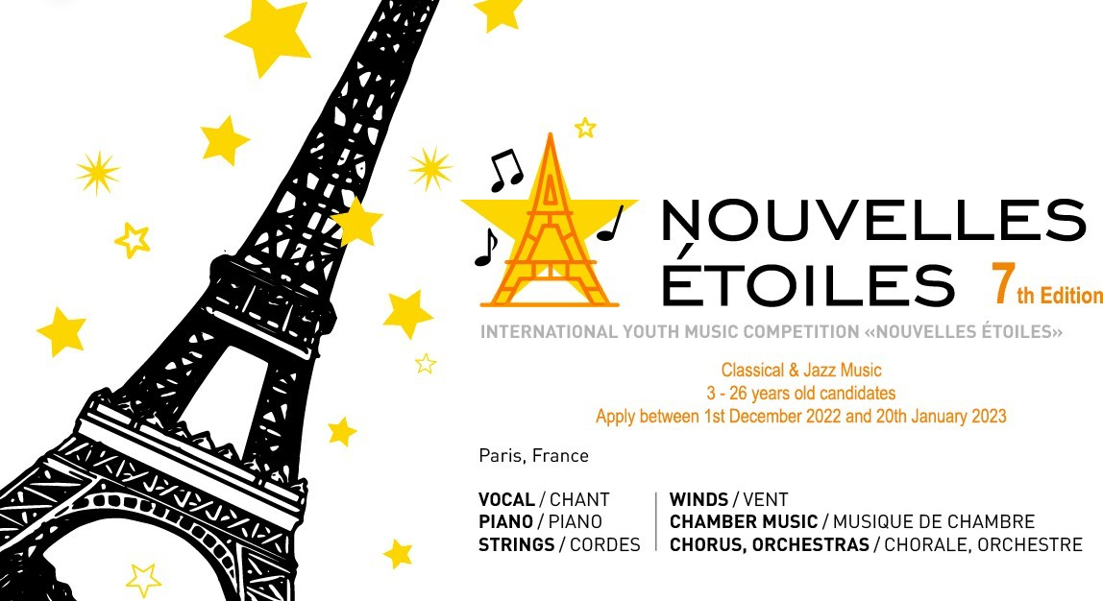

7th Edition
From 1st December 2022 to 30th January 2023
Applications are open until January, 20th 2023

Contact : Mrs Maria Christiany, artistic director E-mail : nouvelle.etoile.competition@gmail.com Secrétariat : +33(0)6 40 11 18 47

ORGANIZERS AND PARTNERS
Nouvelles Etoiles Music Competition (Classic & Jazz) is organized by International Cultural Association ArtimA (Paris, France), directed by Maria Christiany, French violinist and violinist of Russian origin. with the support of :
- CRD Jean Wiener (Bobigny, Grand Paris, France)
- UniArt international orchestra

Diplomatic and cultural organizations
- Violin makers from Cremona Maria Strelnikova and Alessandro Sironi

GOALS
The objective of Nouvelles Etoiles is to discover promising young musical talents and to support their future professional development. The aim of the competition-festival is also to promote cooperation and cultural exchanges between France and other countries.

DATES AND PROCEDURE
The 7th Edition of Nouvelles Etoiles is taking place from 1st December 2022 until 30th January 2023.
Registrations are open until 20th January included and will take place online.
The results will be released from 30th January 2023.
Diplomas and certificates will be sent by email.
The winners of the Grand Prizes and Special Prizes will receive a financial award in addition to their diploma. The Artima association has set up a financial fund to reward the winners of the Grands Prix who will be able to share the sum of 1,200 euros. The Grands Prix are selected from all candidates, regardless of musical discipline, nomination and age category.
The Grand Prizes and First Prizes laureates can be invited to perform the concerts in prestigious halls in France and / or in other countries to be defined, some of which will be accompanied by the international orchestra Uniart. The dates of these concerts will be decided by Nouvelles Etoiles organization committee depending on the global epidemiological situation.
The competition will take place online in a single round.
Our Jury will evaluate the video materials sent by the candidates and select the laureates based on these videos. The evaluation is based on the average score granted by the Jury Members to each candidate.

CATEGORIES
Nouvelles Etoiles 7th Edition is open to 2 musical specialties: Classical and Jazz.
Among these two specialties, candidates will compete in the different music disciplines below:
  - Vocal (academic, folk and pop-jazz)
  - Piano and accordion
  - Wind instruments (wood and brass)
  - String instruments (violin, viola, cello, contra bass, guitar, harp)
  - Any folk instruments performing classical music pieces
  - Music chamber ensembles
  - Orchestras
  - Choirs

For each music disciplines, candidates will compete as:
  - Soloists
  - Instrumental and vocal ensembles (max. 8 participants), including teacher-student ensembles
  - Orchestras, large instrumental or vocal ensembles (from 9 participants).

The competition takes place in two age categories :
  - Little soloist - up to 16 years old,
  - Young virtuoso - up to 26 years old,

The age category for the sets is determined by the average age of the participants.

Soloists will compete in different age groups : Little soloist:
  - Group A: from 3 to 6 years old
  - Group B: from 7 to 9 years old
  - Group C: from 10 to 12 years old
  - Group D: from 13 to 14 years old
  - Group E : from 15 to 16 years old Young virtuoso:
  - Group A : from 17 to 19 years old
  - Group B : from 20 to 22 years old
  - Group C : from 23 to 26 years old

PROGRAM
The competition will take place online, by video recording.
The candidates should send one or two videos of them while performing two pieces (or songs) of different characters. The length of the program (including both pieces) should be up to 15 minutes maximum.
To be noted:
  - Candidates are allowed to play with the scores.
  - We will accept only videos made during the last 12 months (not before).
  - Due to the quarantine, “home” recordings are permitted.
  - Video or audio montages are not allowed.
The video links (1 or 2 links) should be sent at the time of registration by e-mail at nouvelle.etoile.competition@gmail.com via YouTube link (or another similar online video system).
Our Jury will evaluate the video materials sent by the candidates and select the winners based on these videos. The evaluation is based on the average score granted by the Jury Members.

REGISTRATIONS
Modalities:
Registrations must be made by e-mail at nouvelle.etoile.competition@gmail.com and must include the following elements:
- The artistic biography of the candidate in French, English or Russian, with the contact of the candidate, his photo and the name in latin transcription for the diploma.
- Video links of their performances
- A scan of the candidate's passport or identity card
- A proof of payment of registration fees
- The Registration Form in Appendix 1, duly completed or fill out the google form : https://forms.gle/8QQUiPChZuJbf4CR6

Registration fee:
- Soloists : 35 € per candidate
- Ensemble of chamber < 6 people (ex. duo, trio, etc.) : 20 € per candidate
- Ensembles of 6-10 members: 100 € per ensemble
- Ensembles of 11-20 members: 150 € per ensemble
- Grands Ensembles or Orchestras (> 20 members): 200 € per ensemble
The fee must be paid at the time of registration by bank transfer (see details below), Western Union (only for bank transfer), Paypal (centreartima@gmail.com) or Pay Send (FR 76 1820 6001 6060 2728 4185 384) before sending the application form
A candidate or his legal representative can pay online with a bank card. To do this, simply go to the website of the Artima association: https://www.centre-artima.com/ or by clicking directly on the link: https://secure.payplug.com/p/jeiIE2B
For european applicants, it is possible to pay with the Lydia smartphone app on the number
+33640111847.
The bank details for payment by bank transfer are: Artima Association
Bank: Crédit Agricole d'Ile de France Bank code: 18206 / Counter code: 00160 Account: 60272841853 / Key: 84
Iban: FR 76 1820 6001 6060 2728 4185 384 Swift: BIC: AGRIFRPP882
NB: bank transfers must include the title "Nouvelles Etoiles + name of the participant"

All registrations are final and non-refundable.
Discounts & grants:
- Discounts: in case of participation in two or more categories, the registration fee in the additional category is reduced by 50%
- Grants: applicants with limited resources and showing exceptional technical and musical ability may receive a grant for all or part of the registration fee. We invite you to make the request to the ArtimA association, along with supporting documents.
- Candidates who have already benefited from the free admission or a fee discount during a previous edition of the competition cannot benefit from it again, except in special circumstances which will be assessed by the committee of the competition.

RIGHTS
The candidate or his legal representative agrees to the distribution of the videos sent, as well as the photos and all the audiovisual material that may be produced during the concert in the interest of the competition.
The videos of the winners and the Grand Prix can be posted on social networks to determine the audience's prize.

PERFORMANCE EVALUATION
The maximum overall score for a candidate's performance is 100 points.
The score is made up of the sum of the points (maximum 20) received for each of the five evaluation criteria:
- Technical level,
- Respect for stylistic characteristics,
- Level of difficulty of the chosen program,
- Artistic qualities,
- Expression.

DIPLOMAS AND CERTIFICATES
Depending on the result of the jury, participants may receive a diploma or certificate depending on the number of points awarded.
The Grand Prize are awarded to candidates who have received the maximum score of 100 points from the jury; First Prize winners are those who have received 90 to 99 points; Second Prize winners from 80 to 89 points and Third Prize winners from 70 to 79 points.
The Grand Prize videos, as well as those of the First Prize winners, will be posted on the competition's YouTube channel and on Facebook to determine the People's Choice Award.
Candidates who have obtained from 50 to 69 points are graduates (4th, 5th and 6th Prize). Contest participants who received a lower number of points will receive a certificate of participation.
Special prizes may be awarded as a second degree - or the only one - for applicants whose performance / conditions of participation have been exceptional by certain standards.
Laureates will be granted with the following diplomas:
- Diplomas for the winners of Grand Prizes
- Diplomas for the winners of the 1st, 2nd and 3rd Prizes
- Participant's Diplomas for those who finish in 4th or 5th places
- Honour Certificate for the teachers of laureates
- All participants who haven't received a prize will receive a Certificate of Encouragement;
- The winners' accompanists will receive a Thank You Letter (if asked at the moment of registration)
The diplomas will be sent electronically.

Below are examples of diplomas that will be issued by Nouvelles Etoiles:

Diploma Grand Prize Diploma 1st Prize Diploma 3rd Prize
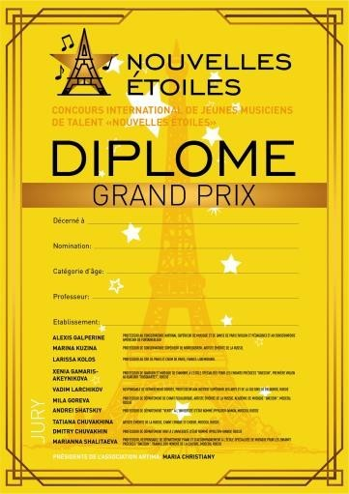
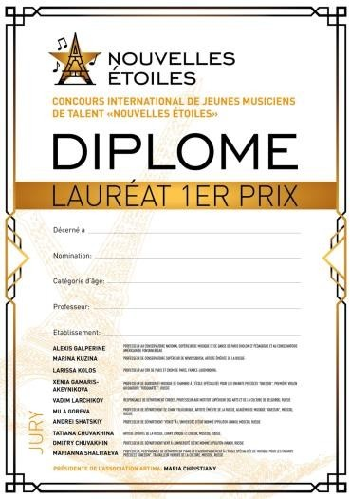
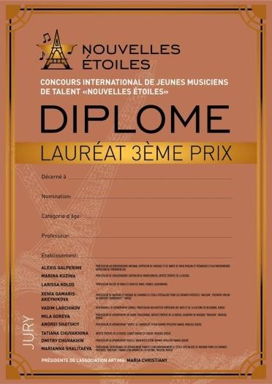

PRIZES AND AWARDS
- The Artima association has set up a financial fund totaling 1,200 euros to reward the winners of the Grand Prizes. The Grand Prizes are determined among all participants, regardless of their musical discipline, category and age group.
- Participation in one or more concert(s) in prestigious Concert halls in France and / or in other countries, sometimes with the accompaniment of an orchestra;
- Prizes and gifts from Nouvelles Etoiles sponsors;
- Participation in Master-Classes animated by renowned teachers;
- Participation in “Nouvelles Étoiles” musical academy, Normandy, France
- Prize of OFJT (orchestre français de jeunes talents), partner of the competition

JURY
The jury of Nouvelles Etoiles is composed of high-level specialists:
- President of the jury : Alexis Galperine. Alexis is a professor at the National Conservatory of Music and Dance in Paris (violin and pedagogy) and at the American Conservatory of Fontainebleau
- Maria Christiany: president of Artima, Professor at the CRD of Bobigny and director of the "Inter Cordes" and "Nouvelles Etoiles" competitions, France
- David Alan-Nihil: Classical and jazz guitarist, David is also a neo-classical composer and author of nearly 600 works, including ten symphonies for string instruments and Les Angélisme, 366 spiritual songs for choirs. David is also the founder of the Parisian festival “Musique Sacrée en Capitale”.
- Jean-Etienne Sotty: accordionist whose creations contribute to the expansion of the repertoire for accordions, co-creator of the first microtonal accordion in France ;
- Tatiana Borysenko: pianist and chamber music teacher at the Glier Academy, Kyiv, Ukraine and piano teacher at the Artima Association, Paris, France;
- Igor Ferlan: concert violinist, leader and solo violinist of the Uniart orchestra, France;
- Xenia Gamaris-Akeynikova: quartet and chamber music teacher at the specialized school for gifted children "Gnessin", first violin at the "Rusquartet", Russia
- Vadim Larchikov: head of the strings department and professor at the Higher Institute of Arts of Culture in Belgorod, Russia

- Victoria Ulianova: Doctor in pedagogical sciences. Professor of music, Theory and methods of teaching, Ukraine, professor of music and choir singing, Association Artima, Paris
- Deborah Tanguy: professor - coordinator of the Department of Jazz at the Jean Wiener Conservatory, Bobigny, France.
- Andrei Shatskiy: professor of the "Winds" department at the State University named Ippolitov- Ivanov, Moscow, Russia
- Tatiana Chuvakhina: distinguished artist in Russia, lyric and choir, Moscow, Russia
- Dmitry Chuvakhin: professor of the "Winds" department at the State University named Ippolitov- Ivanov, Moscow, Russia

ONLINE CONFERENCES & MASTER CLASSES
A series of online conferences and master-classes with the Jury Members and other invited experts will be organized in the frame of Nouvelles Etoiles competition. This will include a professional training to candidates' teachers.
Some of these conferences & master classes will be offered as a prize for selected candidates as well as to their teachers.
These master classes will mainly be held online but, depending on the location of the laureates and of the jury members, some may be offered in person.
All participants to these conferences & master classes will receive a Certificate.

REMARKS
The jury's decision is final and without appeal. Depending on the results of the competition, the Jury reserves the right to:
  - share the prizes among the participants ;
  - not distribute all Prizes ;
  - not distribute Grand Prize ;
  - not award a Grand Prize in each category.

COMPETITION WINNERS ANNOUNCEMENT
- Participants in the competition will be informed of results of the competition and names of the winners from messages posted by the organizers on the official Facebook page and the site of the competition (https://www.necompetition.com), on the date set.
- The videos of the winners and the Grand Prizes may be posted on social networks to determine the People's Choice Award.
- The winners of the Competition who have received financial prizes - or their legal representatives - are required to provide the organizing committee with the participant's personal data (surname, first name, patronymic, address, telephone number, bank transfer account number) and other information necessary to complete the file and to sending money.
- A minor winner of the competition can only receive a prize if the persons, who are the legal representatives, request it, on presentation of supporting documents. Failure to present documents confirming authorization by the aforementioned persons may be deemed a refusal to receive a cash prize.

SPECIAL CONDITIONS
The participants in the Competition authorize the organizers to process and store the data of the candidates and their legal representatives. The contact details (telephone, address, e-mail) of the participants can be used by the organizers to communicate with them, including to inform them about the upcoming events of the Artima Association.

The participant confirms their consent to the publication and free use of photos and videos sent for participation in the Competition, as well as during any filming during a concert in the context of the competition.
The organizers are not responsible for the failure to receive the necessary information from the participant, including due to the fault of the communication organizations, technical problems and / or fraud on the Internet and / or the communication channels used during the competition. Nor can the organizers be held responsible in the event that it is impossible to communicate with the participant due to a lack of contact information or erroneous information, including in the event of the sending of diplomas and prizes in cash to the wrong address, due to a spelling error of the address during registration.
Anything that is not governed by these regulations is governed in accordance with the legislation in force in the French Republic.
If, for whatever reason, the Contest cannot proceed as planned, for whatever reason, the organizers may, at its sole discretion, postpone the dates of the Contest.
By applying to the competition, participants and / or his legal representative automatically accept all the conditions and rules of the online music competition.

TOUR ORGANIZATION FOR THE LAUREATES
The organizing committee of Nouvelles Etoiles competition is in charge of the organization of concerts and rehearsals, advertising, distribution of tickets and invitations to officials and potential sponsors.

The rates and conditions of a possible trip will be discussed on a case-by-case basis.

In case of uncertain epidemiological situation, the organizing committee reserves the right to change the dates of the proposed tour.

CONTACTS

Address: Association ArtimA 17, rue Bleue, 75009 Paris, France Facebook page: https://www.facebook.com/NouvellesEtoilesCompetition Website: https://www.necompetition.com
E-mail: nouvelle.etoile.competition@gmail.com Partnerships & Sponsoring managers:
  - Maria Christiany :+33( 0)640111847
  - Jean-Michel Christiany :+33( 0)684110786
  - Communication manager: Camille Guillain : nouvelle.etoile.competition@gmail.com
  - Trainee: Alexandre Melashvili : nouvelle.etoile.competition@gmail.com

Appendix 1: registration form

REGISTRATION FORM
to participate in the international online music competition

“Nouvelles Etoiles” 7th Edition
Last name and first name: ..........................................................................................................

Date of birth: ..............................................................................................................................

Name of the musical education institution: .............................................................................

Music specialty:

- Classical
- Jazz

Discipline:

- Vocals / Singing
- Piano
- String instruments
- Wind instruments (wood and brass)
- Folk instruments (classical music)
- Chamber ensembles
- Orchestras
- Choirs

Category:

- Soloist
- Instrumental and vocal ensembles (max. 8 participants)
- Orchestras, large instrumental or vocal ensembles (from 9 participants)

Age group:

Little soloist

- Group A : from 3 to 6 years old
- Group B : from 7 to 9 years old
- Group C : from 10 to 12 years old
- Group D : from 13 to 14 years old
- Group E : from 15 to 16 years old
Young virtuoso

- Group A : from 17 to 19 years old
- Group B : from 20 to 22 years old
- Group C : from 23 to 26 years old

Phone number (including country code): ...................................................................................

Address :
.....................................................................................................................................................
.....................................................................................................................................................
.....................................................................................................................................................

E-mail: ........................................................................................................................................

Teacher’s name: ........................................................................................................................

Accompanist’s name: ................................................................................................................

Program with the exact indication of the names and initials of the authors, the name of the works performed and the duration of each piece:

.....................................................................................................................................................
.....................................................................................................................................................
.....................................................................................................................................................

By signing this registration form, the legal representative of the applicant accepts the processing of personal data, as well as the use of photos and videos submitted as part of the competition and their publication on medias. The legal representative also confirms having received, read and accepted the competition rules.

Date: ......... / ......... / .........

Signature:

